**UNIVERSITY OF DAR ES SALAAM**



**COLLEGE OF INFORMATION COMMUNICATION TECHNOLOGIES(CoICT)**

**DEPARTMENT OF ELECTRONICS AND TELECOMMUNICATION ENG**

**(ETE)**

**PROJECT PROGRESS ANALYSIS AND REPORT**

**TITLE: BILINGUAL ELECTRONICS QUEUING SYSTEM**

**NAME: WINOCK ERICK G**

**REG NO: 2021-04-01961**

**SUPERVISOR: PROF. BARAKA MAISELI**

**PROBLEM STATEMENT:**

Unorganized queuing procedures leading to conjunction of customers and delay or low-quality service, in most cases customers are forced to wait on very long ques to wait to be served without an organized order during obtaining a particular service

**LITERATURE REVIEW:**

This project was initially being done by former undergraduate student, A system which could allow customer to take a token and wait patiently and being called by one of the counters while its being displayed on a screen for the customers to see which counter is serving which token, where the systems key features where it being bilingual during the calling of next token/customer however, the system had flaws:

* It could not keep track of taken tokens and served tokens
* It didn’t have a feature or button for returned customers
* The printer was independent from the system
* The system didn’t have a backup when the power is cut-off

**MAIN OBJECTIVE:**

To create a reliable battery-backed queuing system that will contain a simplified input process and also will be able to keep track of available customers and served customers

**SPECIFIC OBJECTIVES:**

* To design a database for available, served and returned tokens/customers
* To implement and test it by one counter then all counters
* To integrate a backup battery on the system
* To connect the thermal printer to the network
* To modify the user interface for display
* To integrate the RFID on the printer
* To implement the whole system
* To test the working system

**METHODOLOGY**

AGILE METHODOLOGY

Agile methodology is an approach to project management and software development that emphasizes flexibility, collaboration, and customer satisfaction. It focuses on delivering small, incremental changes to the project, allowing for continuous feedback and adaptation throughout the development process. Here’s an overview:

**WORK PLAN**

* Familiarize with existing system and components
* Identifying and studying the flaws
* Designing and creating a database
* Test on one device
* Implement and test on all counters
* Gather requirement for battery
* Integrate the battery
* Checking requirements for the printer to be connected to the network
* Formulate a means of connection to the system
* Connect the printer to the system’s network
* Test for performance
* Modify the UI
* Test the system as a whole
* Checking RFID requirements
* Necessary information to be captured in the input
* integrate the RFI

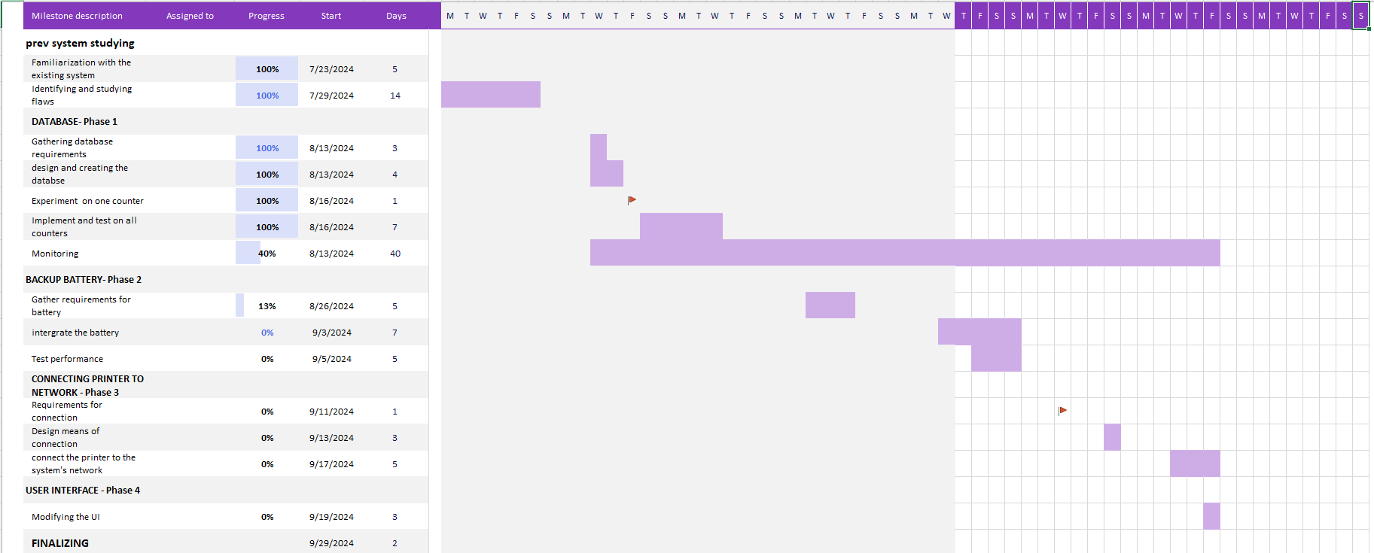

Figure 01: Gant chart on the progress

@prof.kikota Naomba niwe na access ya hii list niweze ku track progress ya kila team kwa wepesi. Kila sub team iwe na effective and clear reporting mechanisms za progress, plans and deliverables ziwe zinaeleweka. Challenges & resolutions ziwe tabled kwa kila sub team, niwe ninaziona at a high level na kuzishughulikia. Mnaweza pia kufikiria kuwa kwenye kila sub team (i.e., kila project) muwe na one person in-charge of that team, sub-team leader; @~Dee J'cob or anayehusika anaweza ku coordinate hizo sub-teams kwa ajili ya ku report kwa Lab Leader @prof.kikota Pengine inaweza ongeza efficiency, especially when the number of projects increase.